Caught stealing
The official scorer shall charge a runner as “caught stealing” if such runner is put out, or would have been put out by errorless play, when such runner [OBR 9.07(h)]:
- Tries to steal;
- Is picked off a base and tries to advance (any move toward the next base shall be considered an attempt to advance); or
- Over slides while stealing
Comment: In those instances where a pitched ball eludes the catcher and the runner is put out trying to advance; the official scorer shall not charge any “caught stealing”. The official scorer shall not charge any caught stealing when a runner is awarded a base due to obstruction or when a runner is called out due to interference by the batter.
The official scorer shall not charge a runner with a caught stealing if such runner would not have been credited with a stolen base had such runner been safe (for example, when a catcher throws the runner out after such runner tries to advance after a ball that had eluded the catcher on a pitch)(a wild pitch or a passed ball).
The notation for “caught stealing” is “CS” followed by the numbers of the players who made the assists and putout. The assist is very often, but not invariably, by the catcher, as can be seen in the following examples. To the abbreviation CS we add in the corner the batting order number of the player at bat at the time of the caught stealing.
Example 97: The runner on first is caught stealing by an assist from the catcher to second base, while player three of the batting order is at bat.
WBSC |  | Traduction dans l’outil de scorage |  | Outil
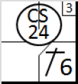 |  | /* Le premier batteur frappe un hit sur l'arrêt court */  action { batter -> 1B6 }  /* Le tente de voler la deuxième mais se fait retirer */  action { runner1 -> CS24 } |  | 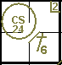

Example 98: The runner on first base is picked off by an accurate throw by the pitcher. He consequently tries to advance, but he is put out by the second baseman on an assist by the first baseman. Assists are credited to the pitcher and the first baseman, and a putout is credited to the second baseman. In this case, no caught stealing is credited to the catcher but to the pitcher. Write the name of the pitcher in a colored row of the catcher box and put a vertical stroke behind this name. By doing this the sum of the stolen bases will be the same as the sum of stolen bases in the offense information.
WBSC |  | Traduction dans l’outil de scorage |  | Outil
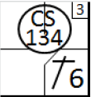 |  | /* Le premier batteur frappe un hit sur l'arrêt court */  action { batter -> 1B6 }  /* Le tente de voler la deuxième mais se fait retirer */  action { runner1 -> CS134 } |  | 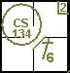

Example 99: When the runner on first base is picked off by an accurate throw by the pitcher, he consequently tries to advance and then returns to first base where he is put out by the first baseman, we write down the complete action. In this example, assists are credited to the pitcher and the first baseman and the shortstop, and a putout is credited to the first baseman. In this case, no caught stealing is credited to the catcher but to the pitcher.
WBSC |  | Traduction dans l’outil de scorage |  | Outil
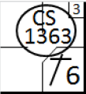 |  | /* Le premier batteur frappe un hit sur l'arrêt court */  action { batter -> 1B6 }  /* Le tente de voler la deuxième mais se fait retirer */  action { runner1 -> CS1363 } |  | 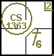

Example 100: When the runner returns to first base safely due to a catching error of the first baseman, we have to write the error as it prolongs the presence of the runner on base [OBR9.12]. Assist will be credited to the pitcher, the first baseman and the shortstop and an error is credited to the first baseman as well. Credit the Caught Stealing to the pitcher.
WBSC |  | Traduction dans l’outil de scorage |  | Outil
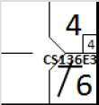 |  | action { batter -> 1B6 }  action { batter -> 1B4 , runner1 -> + }  action { noAdvance on runner1 -> CS136E4 } |  | 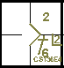

Example 101: ATTENTION: If a runner tries to steal home base and is put out by the catcher, catching a regular pitch by the pitcher, the pitcher is not credited with an assist.
WBSC |  | Traduction dans l’outil de scorage |  | Outil
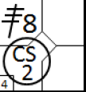 |  | /* Le premier batteur frappe un triple sur le champ centre */  action { batter -> 3B8 }  /* Le coureur tente de voler le marbre mais se fait retirer par le receveur */  action { runner3 -> CS2 } |  | 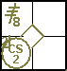

Example 102: The pitcher, realizing the runner’s intention in time, gets down from the plate and throws to the catcher. He is credited with an assist.
WBSC |  | Traduction dans l’outil de scorage |  | Outil
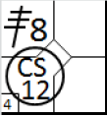 |  | /* Le premier batteur frappe un triple sur le champ centre */  action { batter -> 3B8 }  /* Le coureur tente de voler le marbre mais se fait retirer par le receveur */  action { runner3 -> CS12 } |  | 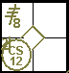
The scorer must therefore pay close attention to the behavior of the pitcher where there is an attempt to steal home base.
Example 103: With runners on first and second, there is a double steal. The catcher plays for the runner on third, but as the third baseman muffs the throw, the runner is safe on third base. Credit an assist for the catcher and an error for the third baseman on the caught stealing play for the runner from second to third and a fielder’s choice to the runner from first to second.
WBSC |  | Traduction dans l’outil de scorage |  | Outil
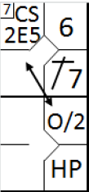 |  | /* Le premier batteur frappe un hit dans le champ gauche */  action { batter -> 1B7 }  /* Le second batteur gagne une base sur 'Hit by pitch', le coureur avance */  action { batter -> HP, runner1 -> + }  /* les deux coureur volent une base, mais un des deux aurait du se faire retirer */  action { runner1 -> O/2 , runner2 -> CS2E5 } |  | 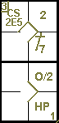

Example 104: With runners on first and second, the runner from second is stealing third base. The catcher makes a good throw, but the third baseman muffs the throw. Seeing the third baseman making an error, the runner from first decides to advance to second base (so not simultaneously with the runner from second). Credit an assist for the catcher and an error for the third baseman on the caught stealing for the runner to third and place the number of the batting order for the lead runner in parentheses in the second base square of the latter runner.
WBSC |  | Traduction dans l’outil de scorage |  | Outil
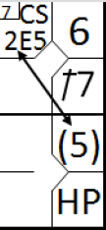 |  | /* Le premier batteur frappe un hit dans le champ gauche */  action { batter -> 1B7 }  /* Le second batteur gagne une base sur 'Hit by pitch', le coureur avance */  action { batter -> HP, runner1 -> + }  /* un coureur vole une base, mais aurait du se faire retirer, le deuxième profite de l'erreur pour avancer */  action { runner1 -> (1) , runner2 -> CS2E5 } |  | 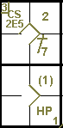

Example 105: With a runner on first base, the batter tries for a sacrifice bunt and fails to contact the ball. The runner, who had already begun to run for second base, tries to return but is put out on an assist by the catcher. In this case also, the reason for the caught stealing should be recorded in the notes.
WBSC |  | Traduction dans l’outil de scorage |  | Outil
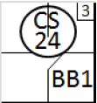 |  | /* Le premier batteur gagne la première base sur un 'base on ball' */  action { batter -> BB }  /* Le coureur en 1 se fait retirer en tentant de voler une base */  action { runner1 -> CS24 } |  | 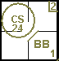

Example 106: A runner on first base, after being surprised by a pick-off, starts to advance to second base, which is seen as an attempt to steal. With an unquestionable opportunity for the defensive to put out the runner, the pitcher makes a bad throw which cannot be caught by the first baseman. As a result the runner reaches second base safely.
WBSC |  | Traduction dans l’outil de scorage |  | Outil
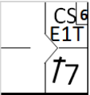 |  | /* le premier batteur frappe un hit en champ gauche */  action { batter -> 1B7 }  /* le coureur vole la deuxième base, il n'est pas retiré à cause d'une erreur */  action { runner1 -> CSE1T } |  | 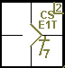

Example 107: In case the runner starts to advance to second base, but returns to first base safely, we still have to write the error since it prolongs the time on base for that runner. Write the error between first and second base.
WBSC |  | Traduction dans l’outil de scorage |  | Outil
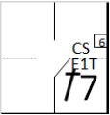 |  | /* le premier batteur frappe un hit en champ gauche */  action { batter -> 1B7 }  /* le coureur tente de voler la deuxième base, il n'est pas retiré à cause d'une erreur, mais il n'avance pas */  action { noAdvance on runner1 -> CSE1T } |  | 